Week 5 – Hardware Development Update

Document Version Number: 3.1

Date: March 28th

Author: Yu Chen Xu

Hardware Version: 3.1

Goal: To explain the updated version of physical model.

Contents

Additional right side sensor 2

# Additional right side sensor

In this week, the major mechanical update is the addition of a new ultrasonic sensor on the right of the robot at 45º.

Before

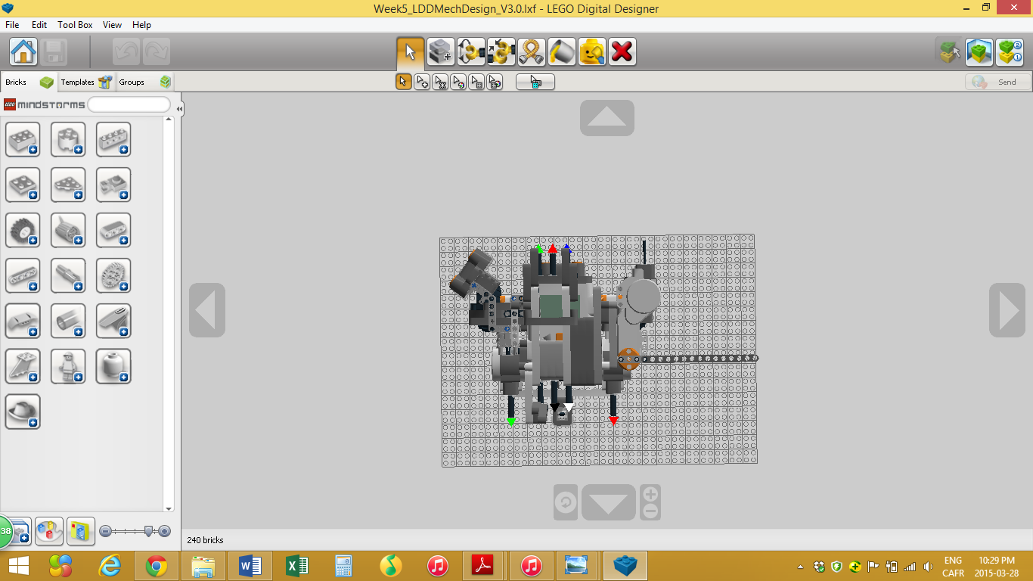

After

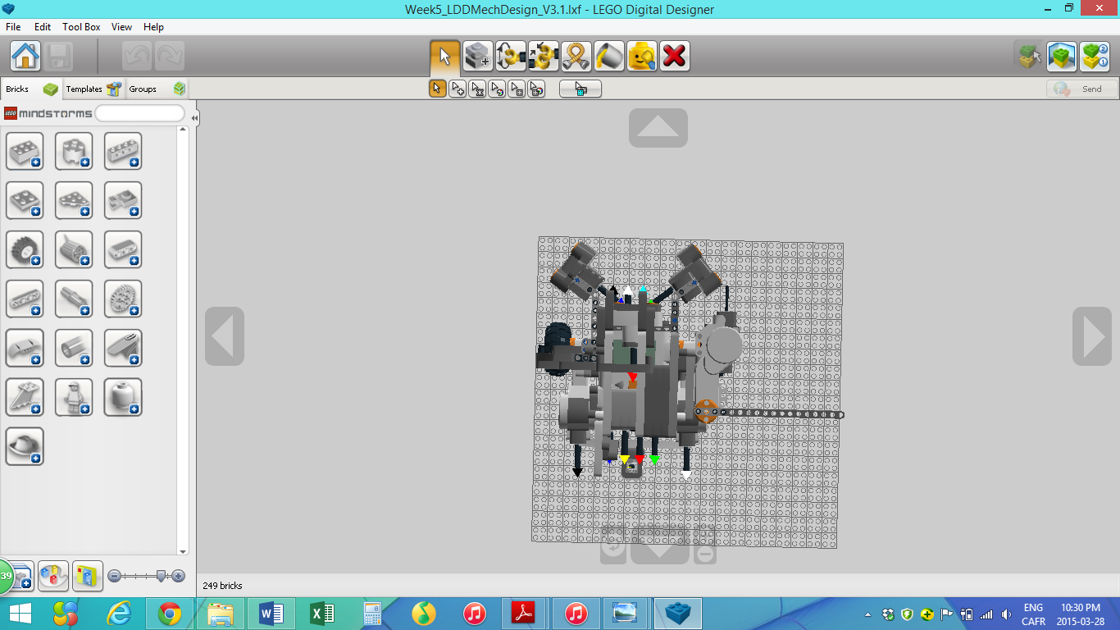

Earlier in the week, the software team decided that putting the sensor at 45º will be beneficial when avoiding obstacles. However, in the last hardware version, only a sensor on the left was implemented. Therefore, some obstacles on the right can’t be detected.

Here, the angle of coverage is even bigger with the addition of a 3rd ultrasonic sensor.

